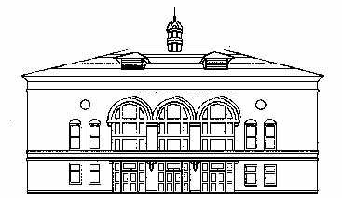
SEATTLE CENTRAL COMMUNITY COLLEGE
VISITOR PARKING PASS

Welcome to Seattle Central Community College!

Please PRINT and PRESENT this complimentary pass to the parking attendant upon entrance to the SCCC parking garage. Parking is limited at Seattle Central Community College during the morning hours. Please allow yourself extra time to find a parking space.

Driving directions:

• Heading South on I-5: Take the Stewart / Denny Way exit, immediately get into the far left lane, turn left on Denny and drive east up the hill to Harvard Avenue, turn right and proceed to the corner of Harvard and E. Pine. SCCC parking garage is located on the right hand corner.

• Heading North on I-5: Take the Olive Way exit, drive east on Denny to Harvard Avenue, turn right and proceed to the corner of Harvard and E. Pine. SCCC parking garage is located on the right hand corner.

DISCLAIMER: This parking pass is valid for the date issued only (one day). Please park and lock your vehicle. SCCC management declares itself not responsible for fire, theft, damage, loss of vehicle, or any article/content left in same. All such risks are being assumed by the holder of this pass. Only a license to park is granted and no bailment is created.

SCCC - HARVARD PARKING GARAGE 1609 Harvard
Avenue, Seattle, WA 98122 * 206-934-6932

This pass must be initiated and completed by the requesting department/division to be VALID. Please include all appropriate information, including mail stop and budget number. This pass, once completed by the requesting office, should be sent/mailed DIRECTLY to the visitor. For last minute request, the pass may be sent/given to SCCC parking attendant PRIOR to your guest’s arrival.

Use the TAB key to move to the next field.

VISITOR INFORMATION
DATE: Click or tap here to enter text.
TIME OF ARRIVAL: Click or tap here to enter text.
NAME OF EVENT: Click or tap here to enter text.
NAME OF VISITOR: Click or tap here to enter text.

REQUESTER INFORMATION
AUTHORIZED BY: Click or tap here to enter text.
DEPT/DIV: Click or tap here to enter text.
MAILSTOP: Click or tap here to enter text.
PHONE NUMBER: Click or tap here to enter text.
BUDGET #: Click or tap here to enter text.
$10 per vehicle to be charged to this budget

