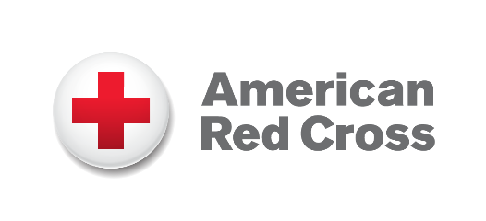

**VOLUNTEER**

**Hot Sheet**

**The mission of the Red Cross is to prevent and alleviate human suffering in the face of emergencies by mobilizing the power of volunteers and the generosity of donors**.

**Disaster Duty Officer (virtual)** - Document incoming disaster notifications. Dispatch disaster responders and monitor the response to ensure appropriate resources are made available. Activate health services, mental health, spiritual care, or public affairs as needed. Training provided. Must have phone and computer with access to the internet. Time commitment is three to four monthly on-call shifts, choose day or night, 12 hours each.

**Disaster** **Action Team (in person)** – When an individual or family are displaced by fire, storms or other emergencies, you can provide support by assisting with access to shelter, clothing, food and comfort. Time commitment is three to four monthly on-call shifts, choose day or night, 12 hours each.

**Disaster Recovery (virtual)** - Provide follow up and recovery planning services, including referral for individuals and households following regional events, primarily home fires. Time commitment is flexible with a scheduled commitment.

**Disaster Shelter/Feeding (in person)** - Due to predictions for an active wildfire season, the Red Cross will need hundreds of volunteers to care for people when disasters strike. Train now to be a Ready Red Cross Shelter or Feeding Volunteer so you can answer the call when people need it most! Time commitment varies by disaster, typical shifts can be up to 12 hours.

**Discover the role that’s right for you!** Explore a wide range of positions based on your interest and time commitment – from teaching community classes like Hands Only CPR to youth preparedness education and community outreach to supporting the local military community and special events.

We are as diverse as the people who receive Red Cross services. We are all different ages with different backgrounds and skills – and together, we deliver the Red Cross mission in our communities.

As a Red Cross volunteer, you can help your community prepare for and respond to emergencies, deliver hope and comfort, meet new people – all while making a huge, positive impact on the lives of those who need it most.

To learn more, visit [**redcross.org/volunteer**](https://volunteerconnection.redcross.org/?nd=lead&a=21381&h=960&p=132914) or scan the QR code

Lindsay Taylor | (360) 790-2987

JoinUsNW@redcross.org