Budget Committee Recommendations to President’s Cabinet

The Resource Allocation Sub-Committee (RASC) of the College Council met to create a recommendation for funding one-time money requests. The Committee met eight times over three months to develop a process, create a request form, create criteria and a scoring rubric, review and rank one-time money requests, and provide supplemental information.

The requests form (see Appendix A) is the consolidation of three forms used during previous budget processes. While the consolidation streamlined the process, the RASC created the first set of questions on the form to elicit the information necessary to evaluate the budget requests.

Departments submitted proposals to their vice presidents who prioritized the top $.5M in requests and forwarded them to the committee for ranking. The committee recognized some regulatory compliance issues as high priorities and designated them as such in the ranking system.

The evaluation rubric (see Appendix B) was used by each of the members to evaluate the budget proposals that were submitted. Committee members were not allowed to rank proposal that came from their department, a department they managed or one in their chain of command. Two groups were formed. Each evaluated half of the proposals; those that did not fall into their work area.

The numerical scores resulting from applying the rubric created the ranking in Table 1 (see page 3 - 4) which is the RASC recommendation to Cabinet for the funding of the budget requests.

The table includes the item #, title of the request, department that made the request and the amount requested. In some cases the VP of an area reduced the amount requested when compared to the original request in order to stay under the $.5M ceiling.

The items ranked “high” were almost all related to regulatory compliance. The numerical ranking represents the rank order that resulted after the average score on the rubric was converted. Sometimes the difference was small at other times it was larger. In some cases multiple items received exactly the same score. In these cases, those items received the same ranking.

Lessons Learned

The committee had a number of observations about the budget requests, the rubric and the process that deserve a few comments. Some of the proposals were scant and the authors lack of effort to present a compelling business case to the committee impacted their score. The Regulatory Compliance criteria on the rubric should be reworked or eliminated in the next budget cycle. Regulatory compliance of more a nominal measure does not mix well onto the ordinal scale used for all the other evaluative criteria in the rubric. Committee members thought that innovative projects should be rewarded in future years by adding to the rubric a criteria for Innovation with a weighting factor to evaluate those projects.

After the ranking was complete committee members noted that some ranking may be skewed because the rubrics evaluative criteria have a bias toward instructional programs. In the future the committee recommends creating more equity in the opportunity for funding by adding criteria that are favorable to the functional areas of the college. Table 2 (see page 5) is to provide perspective on the ranking of each groups. One group scored mostly instructional programs. The other group scored mostly functional areas of the college.

After the ranking was complete committee members noted that some ranking may be skewed as a result of having two different groups scoring different budget requests. Inter-rater reliability can be an issue when many people are using the same instrument but separating the effect of this from the impact of the instructional skew in the rubric is problematic. The committee believes most of the impact of this is averaged out among the scores. Table 3 (see page 6) illustrates rankings that have been statistically adjusted to compensate for one groups lower average scores. While this is not a theoretically sound adjustment to make the committee thought this perspective was important to share in anticipation of questions from Cabinet.

Committee members noted the process we first agreed to and shared evolved over the life of the project based on feedback from, and consensus among, committee members. Notable among these changes was the initial decision to invite people to give two minute presentations related to their requests. Feedback indicated that a few minutes was not sufficient time to understand complex issues and introduced another bias in favor of people with strong speaking skills. It was noted that a poor idea presented well often prevails over a good idea presented poorly. In the end, that budget request form did elicit all the information necessary to make decisions about the requests that were submitted.

Table 1 – RASC Recommendation to Cabinet

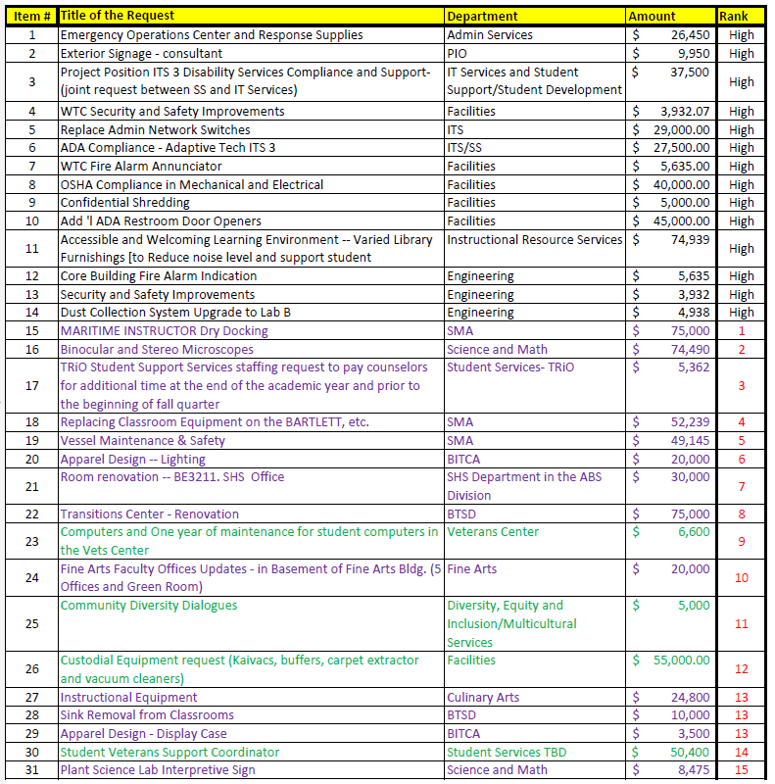

Table 1 – RASC Recommendation to Cabinet (continued)

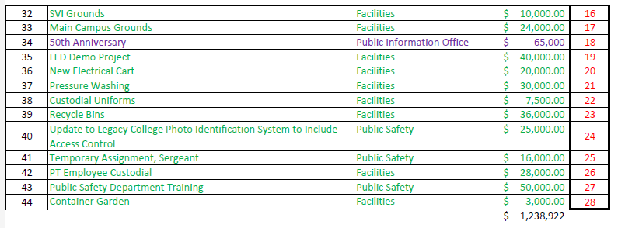

Table 2 – RASC Subgroup Scores for additional perspective

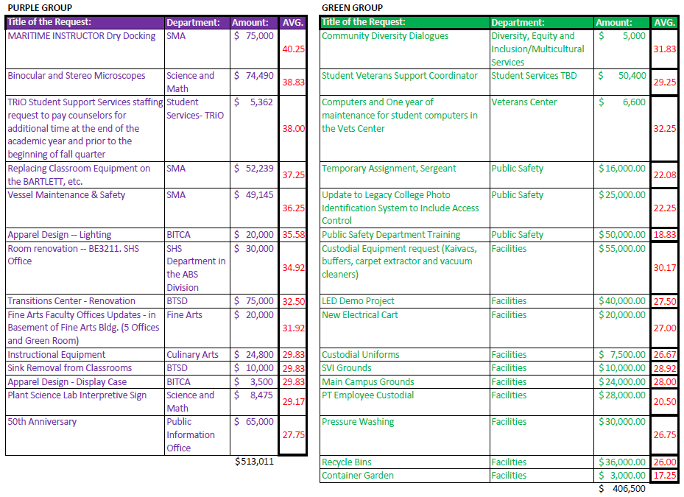

Table 3 – RASC Subgroup Scores with statistic adjustment

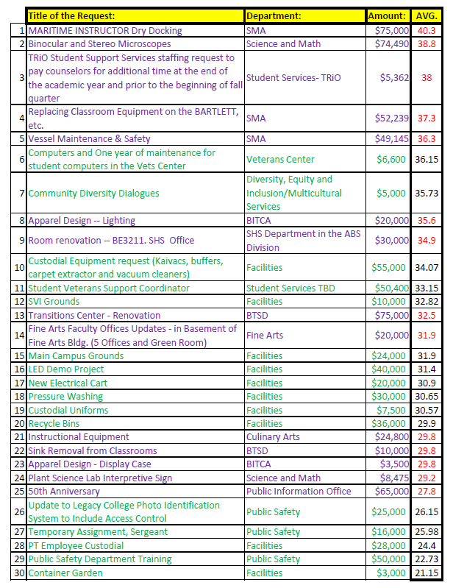

Appendix A – The One-Time Budget Request Form

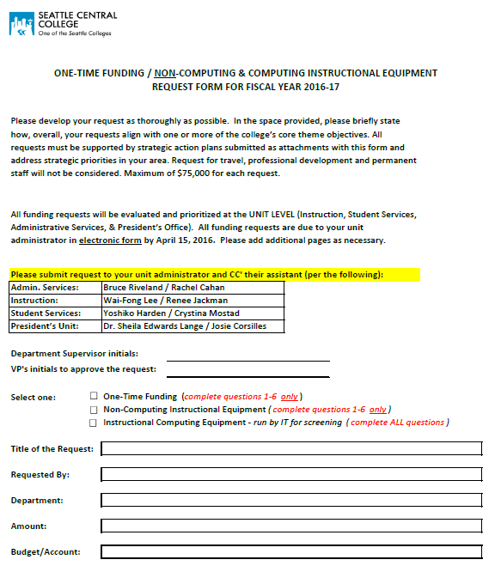
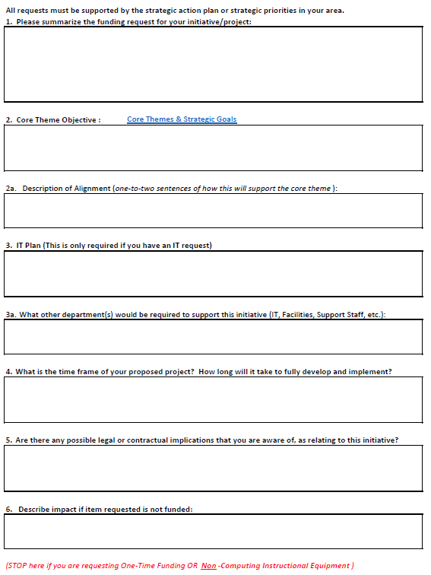
Appendix B – Rubric

